Encrypted Notes App – Project Documentation
1. Introduction
This project is a secure Android application developed using Kotlin and Jetpack Compose. The purpose of the app is to allow users to create, edit, and delete personal notes while ensuring data security through encryption and local database storage.
The application implements modern Android development practices including:
- Declarative UI using Jetpack Compose
- Local data storage using Room Database
- Navigation between screens
- Basic authentication (Login & Registration)

🔹 2. Features
The application includes the following core features:
- User Registration
- User Login (validated using Room database)
- Add new notes
- Edit existing notes
- Delete notes (with confirmation dialog)
- Logout functionality
- Data encryption for note content
- Clean and user-friendly UI
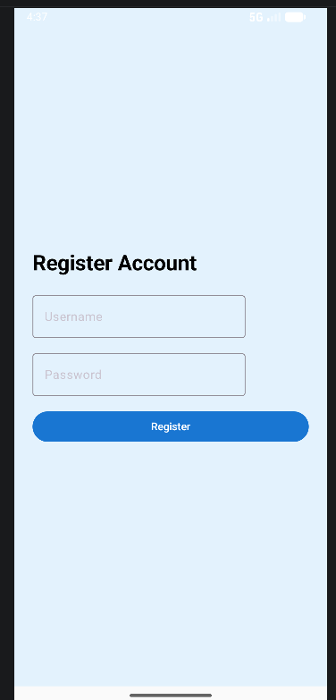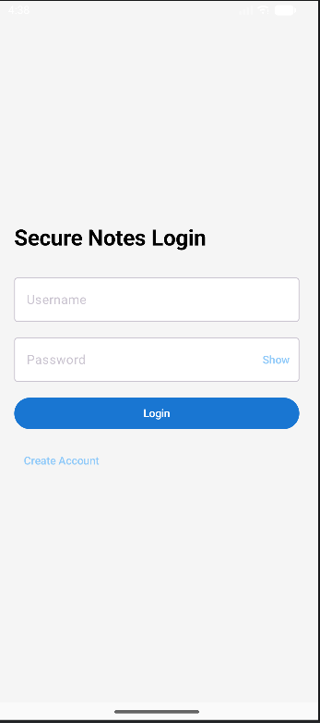
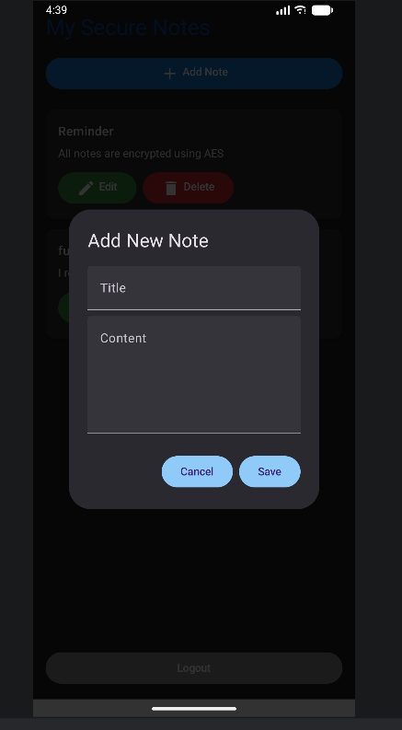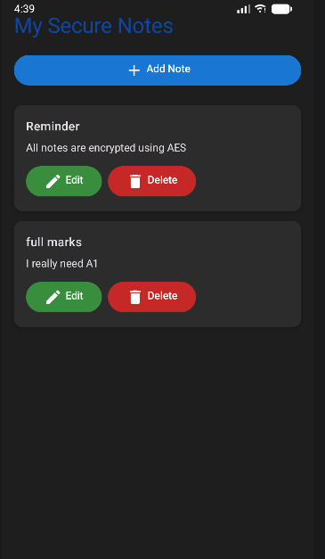


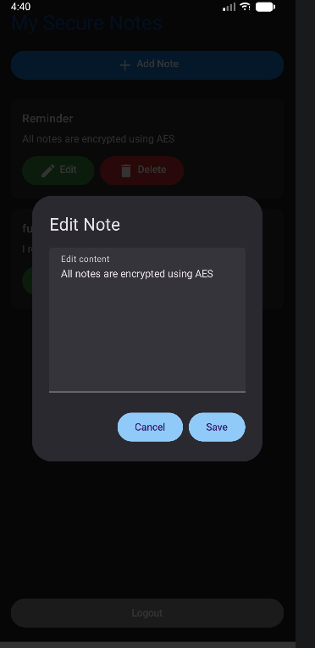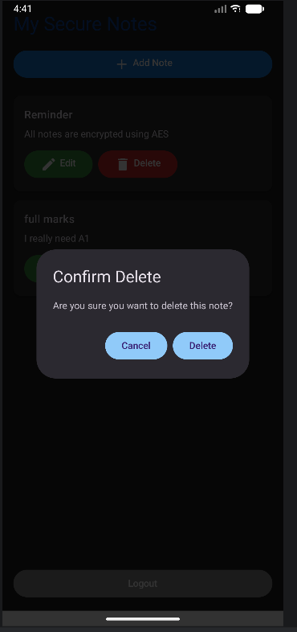

🔹 3. Technologies Used
- Kotlin – Primary programming language
- Jetpack Compose – UI development
- Room Database – Local data persistence
- MVVM Architecture – Separation of concerns
- Navigation Component (Compose) – Screen navigation

🔹 4. Application Architecture
The app follows the MVVM (Model-View-ViewModel) architecture:
Model
- Note.kt – Represents note data
- User.kt – Represents user data
DAO (Data Access Object)
- NoteDao.kt – Handles CRUD operations for notes
- UserDao.kt – Handles user registration and login queries
Database
- AppDatabase.kt – Main Room database configuration
Repository
- NoteRepository.kt – Acts as a bridge between DAO and View Model
ViewModel
- ViewModel.kt – Handles business logic and UI data
UI Layer
- LoginScreen.kt
- RegisterScreen.kt
- NotesScreen.kt

🔹 5. Database Integration
The application uses Room Database for local storage.
Features:
- Stores notes and user credentials
- Supports CRUD operations:
  - Create → Add note
  - Read → Display notes
  - Update → Edit note
  - Delete → Remove note
🔹 6. Authentication System
The app includes a simple authentication system:
✔ Registration
- User enters username and password
- Data is stored in Room database
✔ Login
- Credentials are validated against stored users
- If valid → navigate to notes screen
- If invalid → show error message

🔹 7. Navigation
Navigation is implemented using NavHost.
Screens:
- Login Screen (login)
- Register Screen (register)
- Notes Screen (notes)

🔹 8. UI Design
The UI is built using Jetpack Compose and follows Material Design principles.
Enhancements:
- Dark theme support
- Colored buttons for actions (Add, Edit, Delete)
- Confirmation dialog for deletion
- Responsive layout
- Improved readability and spacing

🔹 9. Security Implementation
To ensure data security:
- Note content is encrypted before saving
- Decryption occurs when displaying notes
- Prevents plain-text storage of sensitive data

🔹 10. Challenges Faced
- Managing navigation between multiple screens
- Handling state in Compose
- Debugging Room database integration
- Fixing UI visibility issues (buttons and layouts)
🔹 11. Conclusion
This project demonstrates the development of a secure and functional Android application using modern tools and architecture. It successfully integrates UI, database, navigation, and basic security practices.

